Stream Tables

## A How-To Guide

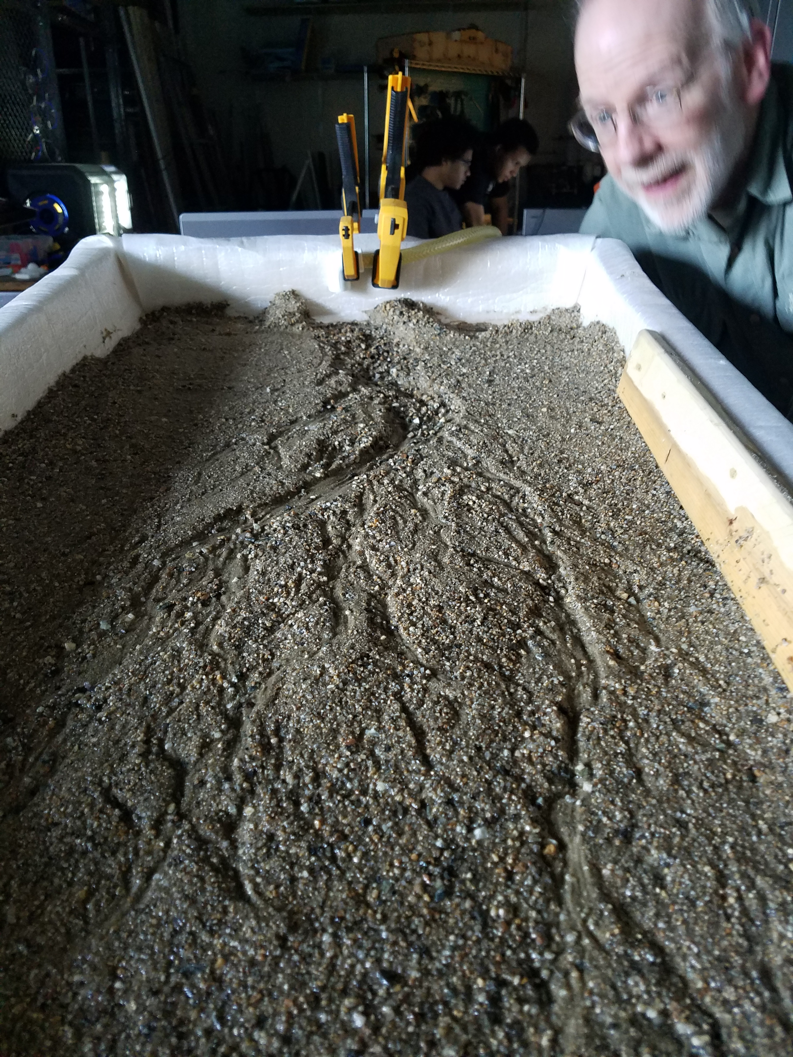

# Foreword

Stream tables are designed to show the formation and effects of water flow over a much shorter timescale. Whereas the effects of water and erosion can be seen in a snapshot, the stream tables allow changes that normally take years or decades to been seen in an overnight or even a 30 min run.

While the basic design of the table is described in this guide, teachers and students are encouraged to try new things. Angles can be changed, different types of sand/sediment can be used, existing features can be added, etc. The real engineering comes through experimentation. Our own experimentation means you’ll see pictures of different designs and materials throughout this guide.

Students are also encouraged to draw conclusions between what they see here and in nature. Looking at the results after running water through the system, you can see things like river deltas, sandy shoals along river banks, and places where finer or coarser sand gets deposited by the water as it flows by.

For safety, do also remember that this table will be quite heavy, power tools will be used in construction, and we are dealing with water and electronics. Respect for tools and each other in a shop space is essential, and should be instilled early in the class.

# Materials

* 2 2”x8” x 8’ lumber
* 2 2”x4” x 8’ lumber
* 2 30”x48” x 3/8” plywood
* Wood screws
* 6mil plastic sheeting (10’ x 25’ roll)
* 2’6” square wire mesh
* Cheesecloth
* 2 10-pound bags of sand
* 1 C-clamp
* 3 quick clamps
* 500 gph bilge pump
* 5’ clear plastic tubing
* 12V power supply
* Rags

# Tools

* Reciprocating saw
* Hand drill with screwdriver attachment
* Drill bits for pilot holes
* File
* Staple gun
* Hammer

# Part One: Building the Box

1. Cut the 2”x8” lumber into two 4’ lengths and three 2’3” lengths.
2. Cut the 2”x4” lumber into five 2’3” lengths.
3. Attach 4 of the 2”x8”s to a 4’x2.5’ sheet of plywood with wood screws (drilling pilot holes for each screw), as shown below:

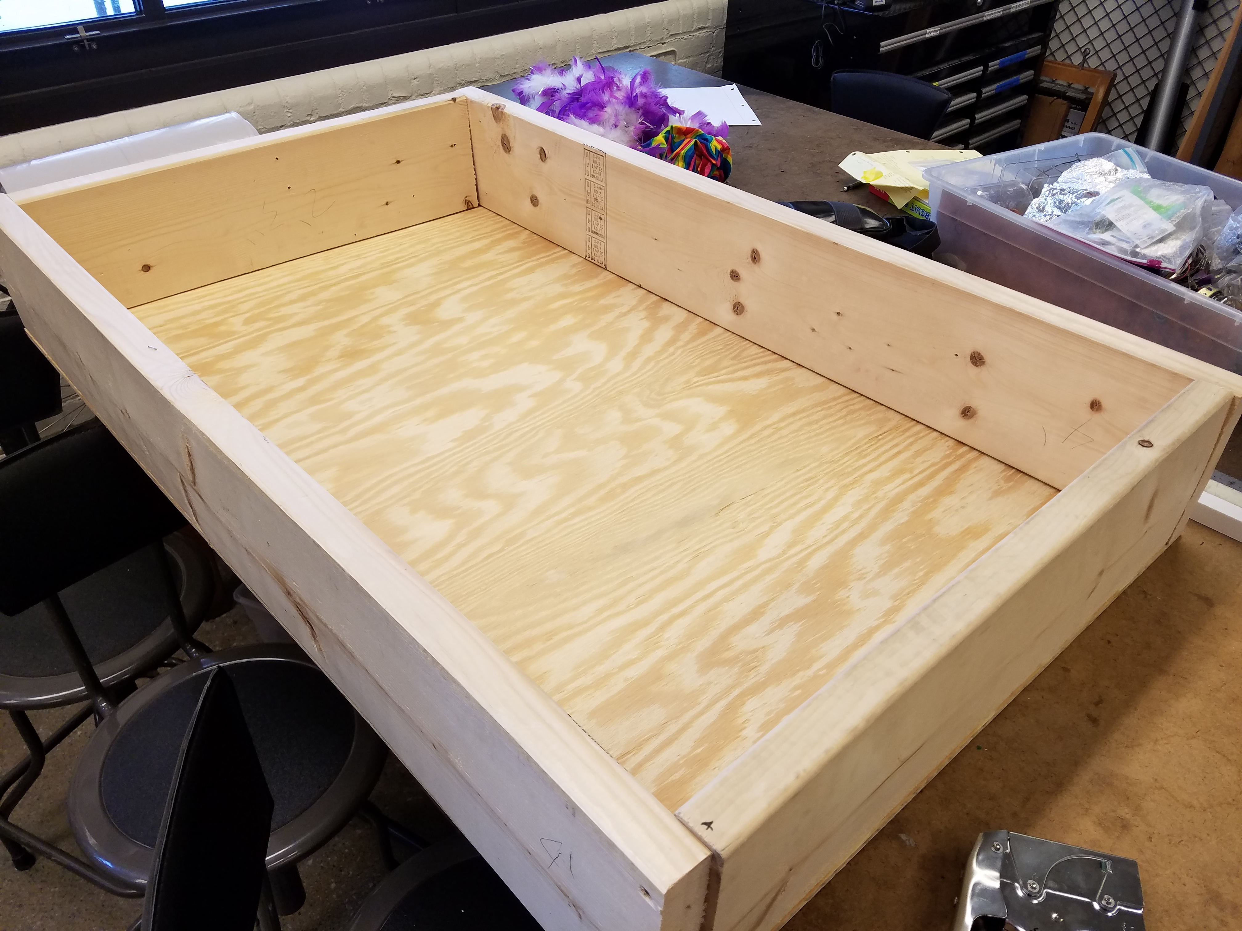

1. Next, file off the sharp corners of the box for safety.

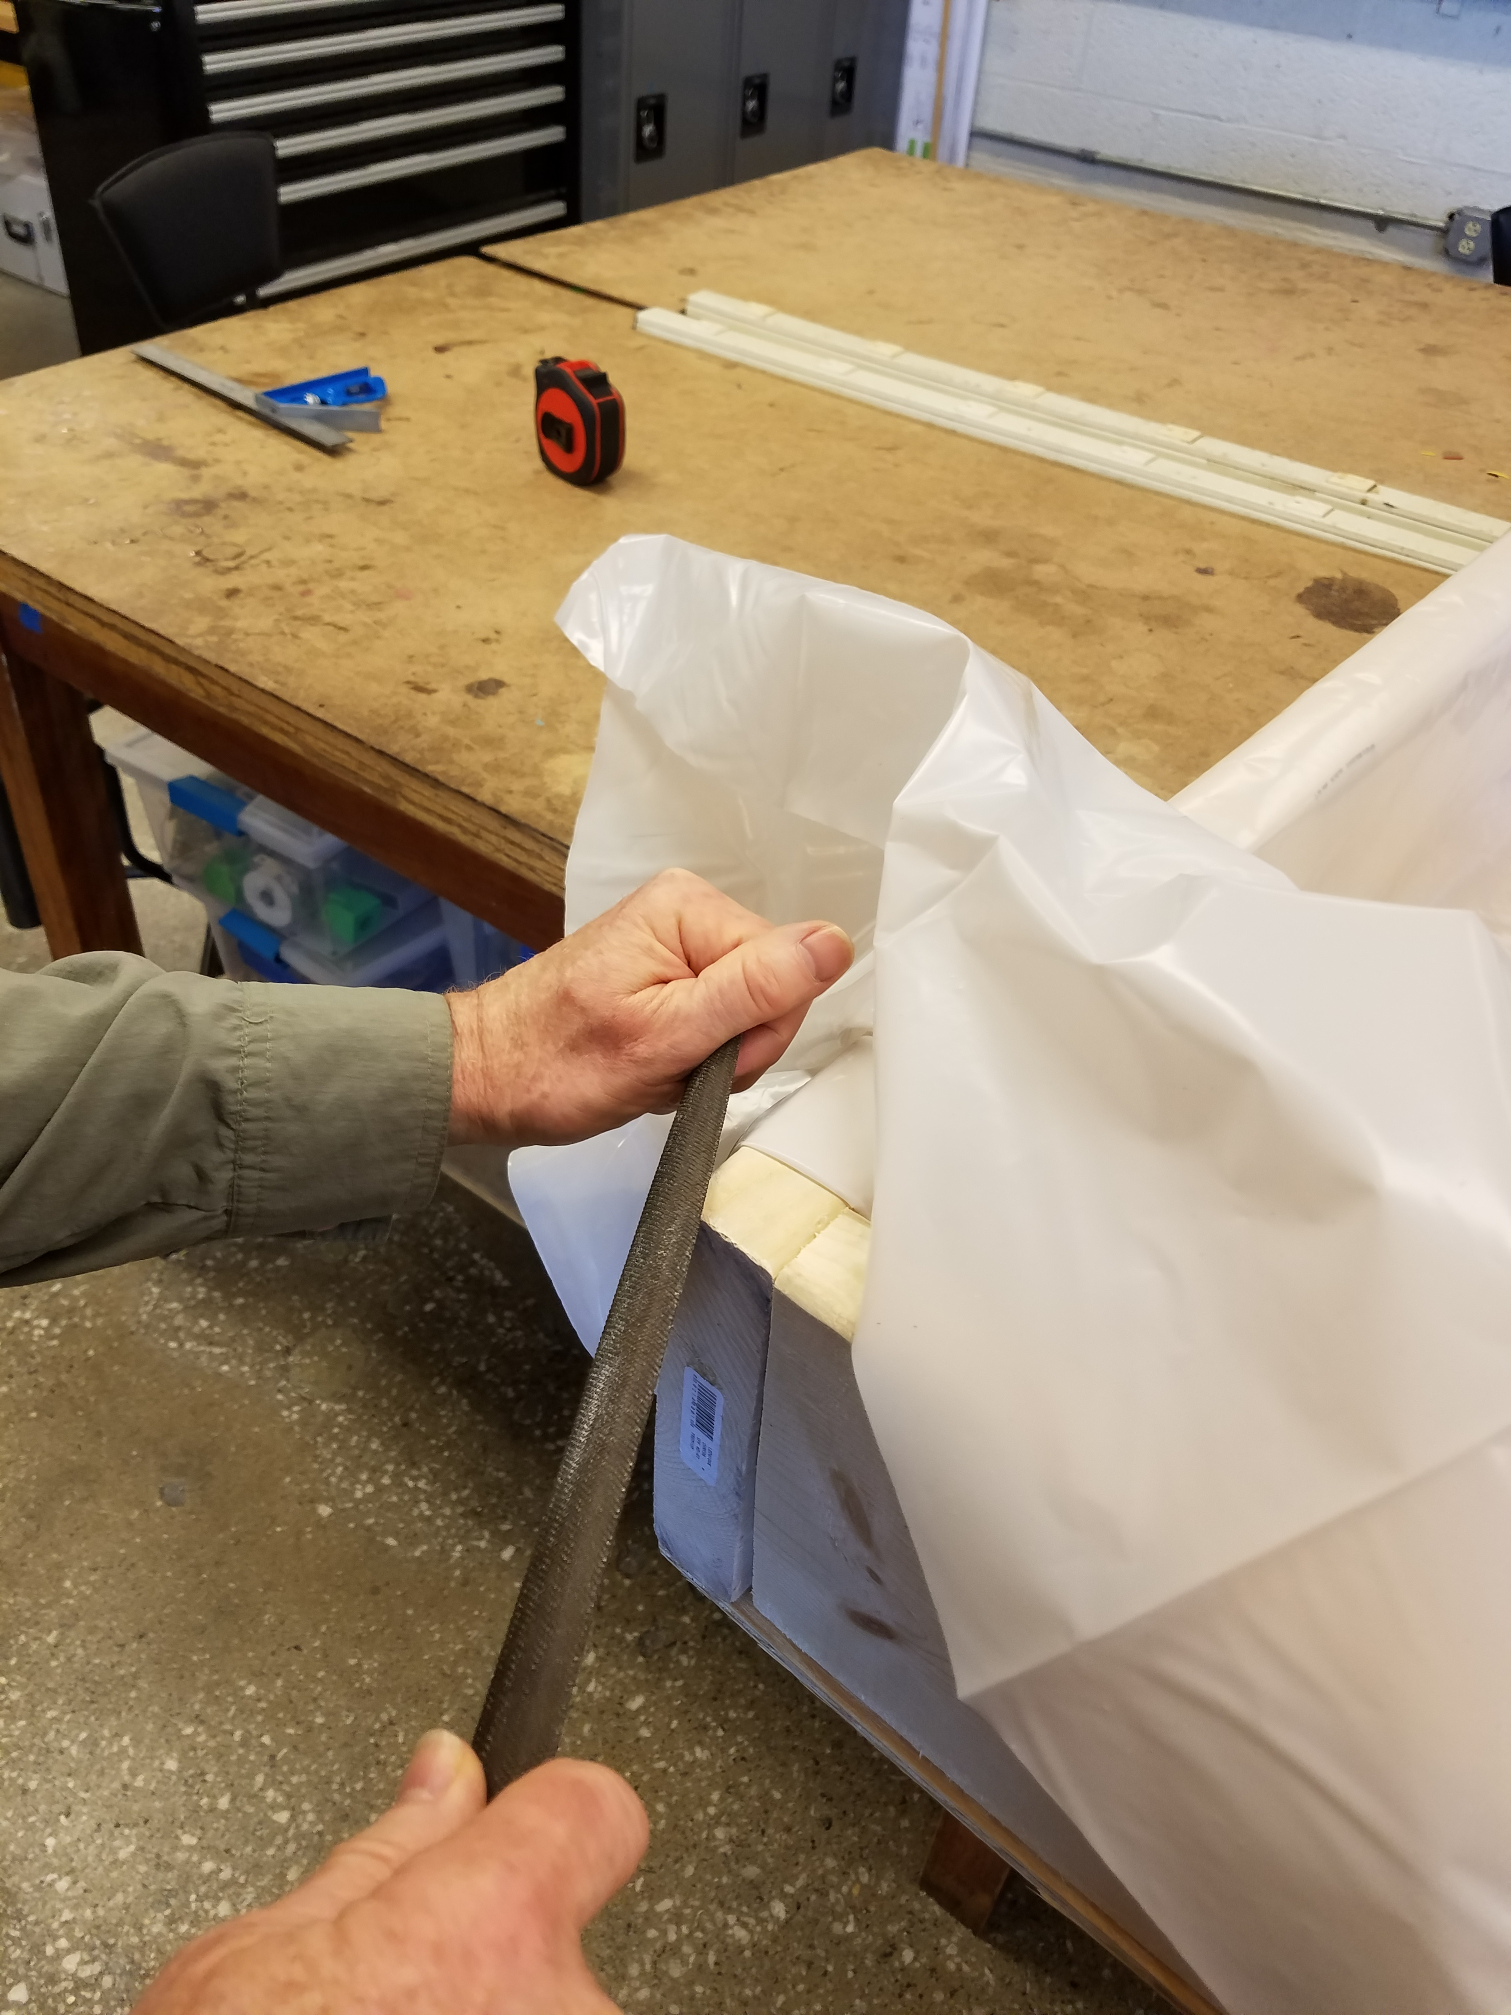

# Part Two: Waterproofing

1. Cut a piece of 6 mil plastic approximately 7.5’ in length.
2. Take the 7.5’ x 10’ piece and cut it in half to make two 7.5’ x 5’ lengths.
3. Center one piece of the plastic in the middle of the box (you can use the creases for reference).
4. Fold one short side over to line up with the inside edge of the box, as shown below:

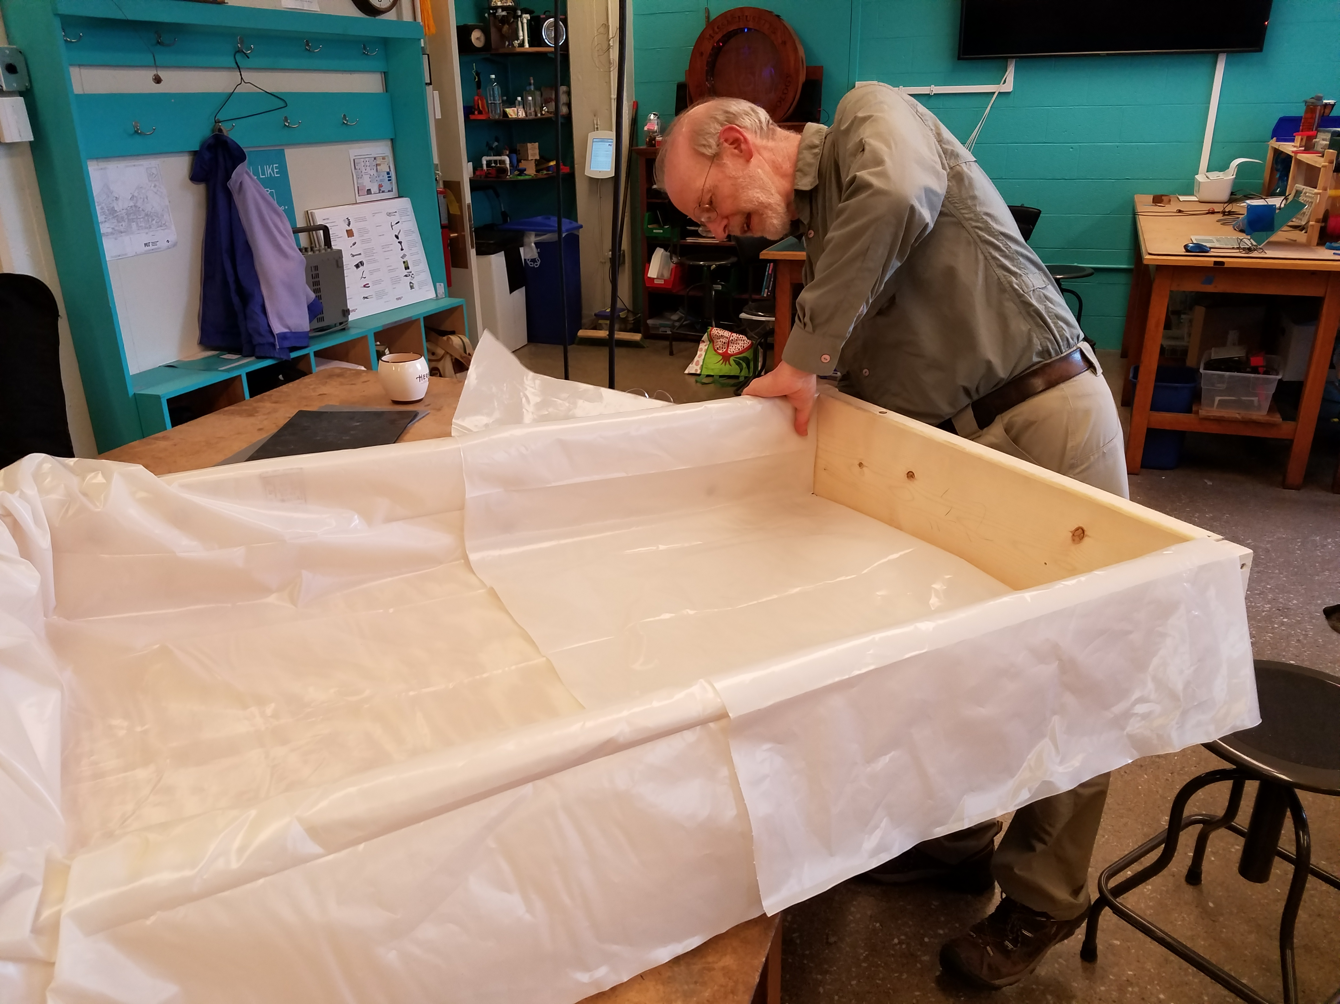

1. Double up the plastic near the outside edge and staple it to the box. (NOTE: DO NOT staple anywhere *inside* the box, since this will poke holes in the waterproof layer.)
2. Fold the plastic over the short edge, gathering the extra material down the side of the box, and staple shut, as shown below:

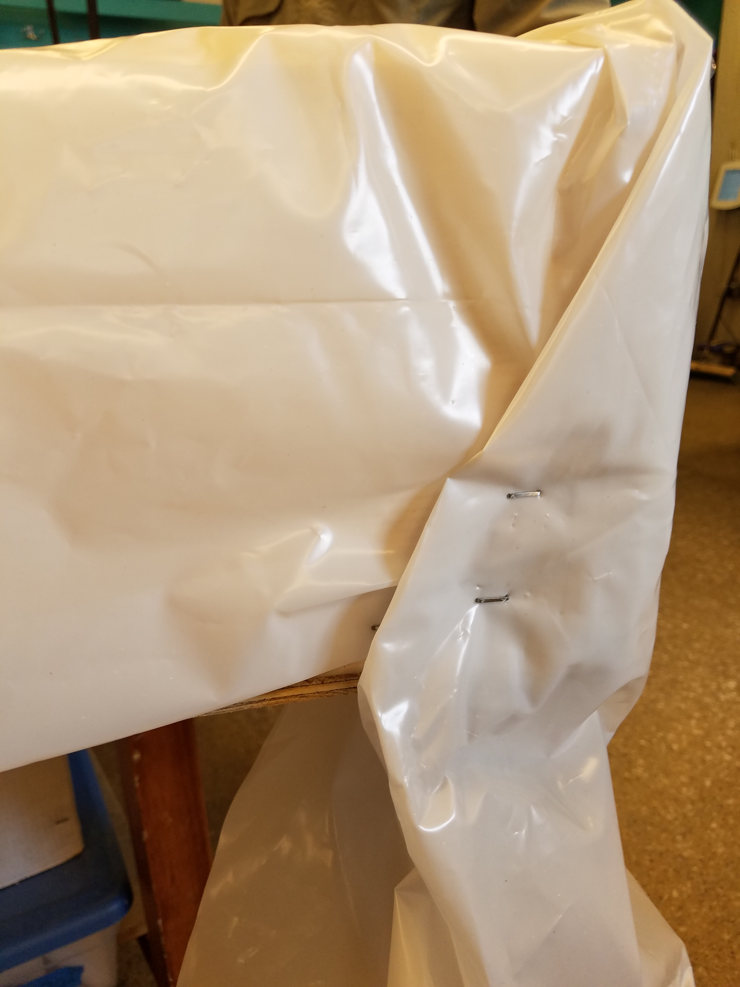

1. Repeat steps 4 through 6 for the other side of the box, then staple plastic down as necessary. You should end with a waterproof container similar to the one below:

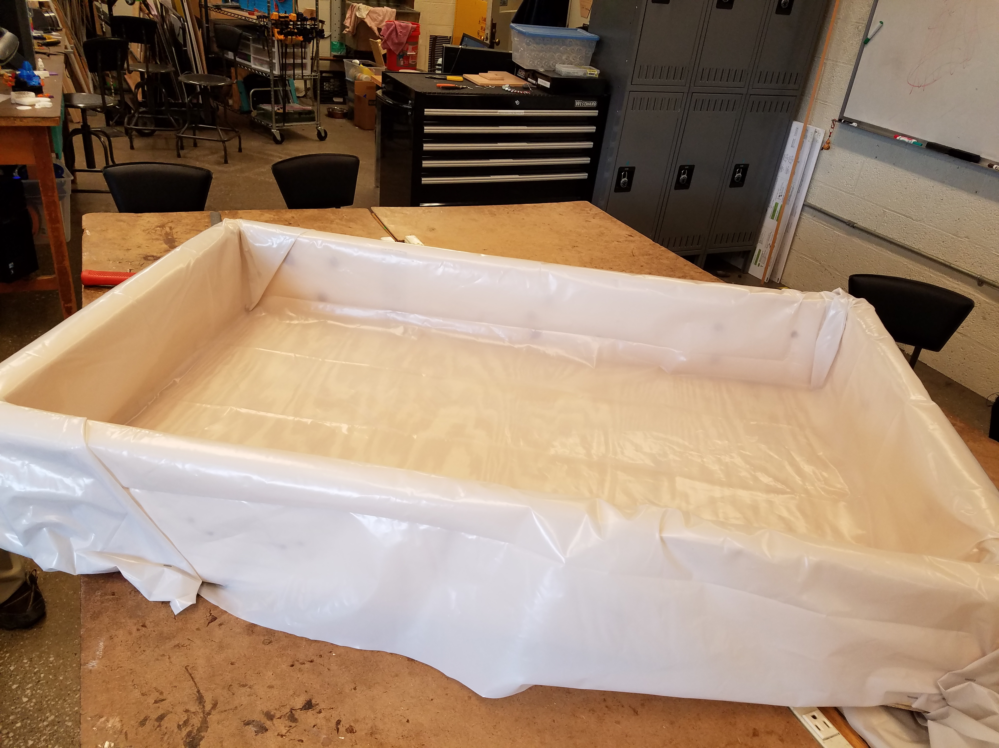

1. Staples sticking out past the plastic can be hammered flush.

# Part Three: Pumps and Filters

1. Take a piece of cheesecloth the width of the box and roll it into a tight tube.
2. Take a piece of wire mesh of the same width and wrap it around the cheesecloth. You should be left with a two-layer filter. Place this filter near what will be the “low end” of the table, leaving enough room for the bilge pump (~3”).
3. Fit the plastic tubing to the output end of the bilge pump, making sure that the tubing can reach around the side and back to the middle of the “high end” of the table. Tape can also be used to make a good seal if necessary.
4. Hold the bilge pump in the desired location, using a quick clamp if desired. Make sure that the intake end of the pump is flat against the bottom of the box. Your final filter/pump setup should look similar to the one below:

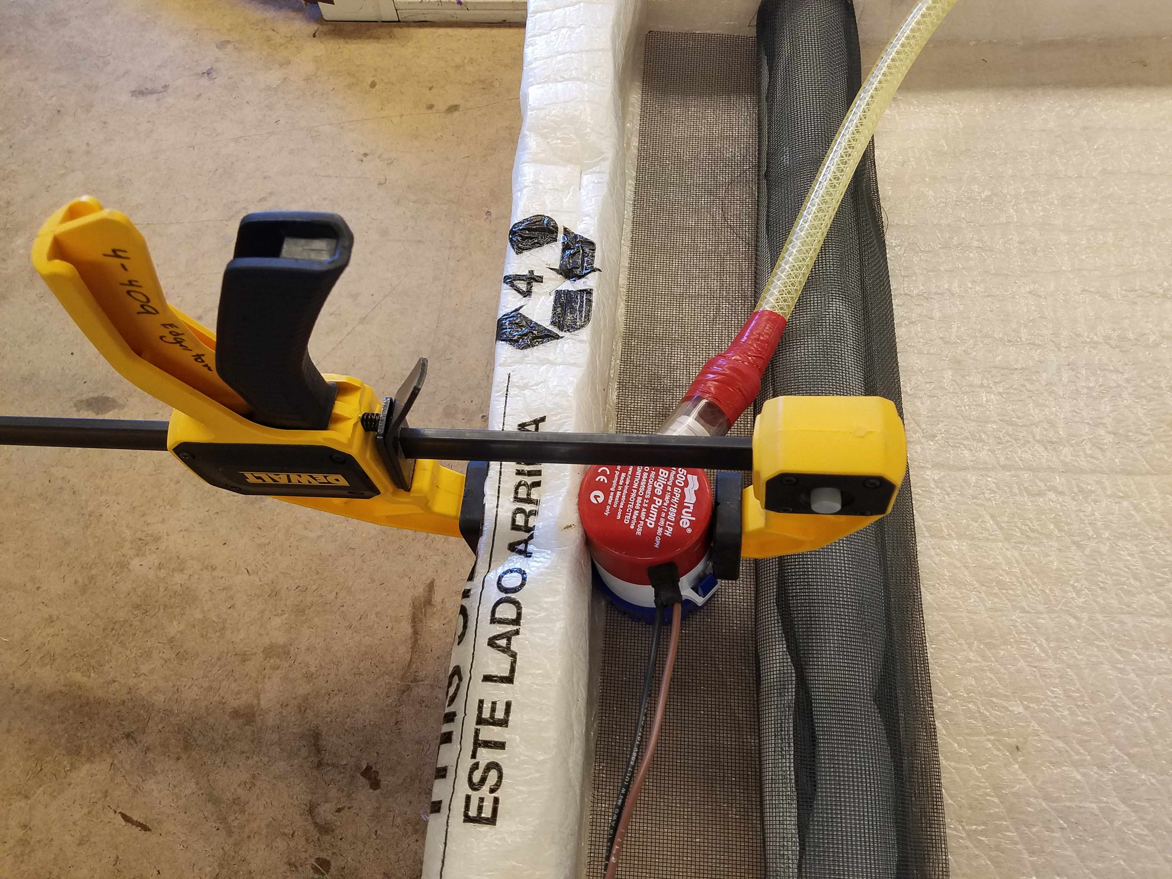

# Part Four: Controlling Water Flow

1. Quick clamps can be used to hold the tubing in place both along the side of the box and at the “high end” where the stream will begin.
2. Your heavier C-clamp can be used at any point along the tubing as your sort of master flow control valve. We recommend starting with the tube all but squeezed shut, and then opening the flow as needed.
3. With your tubing in place, pour your sand into the container to a level even or below with the cheesecloth in your filter. This will prevent any sand that is big enough to go through the wire mesh from getting to the bilge pump.
4. Plug the wires connected to your pump into you 12V power supply.
5. Start adding water to the area around the bilge pump until the water is about halfway to the output tubing. When you turn on the power supply, the pump should be able to pump water smoothly (without sputtering) to the “high end” of the table.
6. At this point, water will start seeping into the sand. It’s likely, as the sand absorbs the water, you will have to add more water by the pump to maintain a good flow.

# Part Five: Making a Stream

1. Use 2”x4”s laid flat on top of each other to elevate the “high end” of the table.
2. What angle you choose will determine how quickly the water flows, which has two main effects: 1) faster water flow leads to more rapid changes in the stream’s structure (and a shorter necessary run time) and 2) faster water flow makes for a more direct stream, rather than a meandering one. Somewhere in the 5- to 10-degree range is a good place to start.
3. A good idea for the start of your stream is to bunch up sand around the end of your plastic tubing to make the stream start from a point, as seen below:

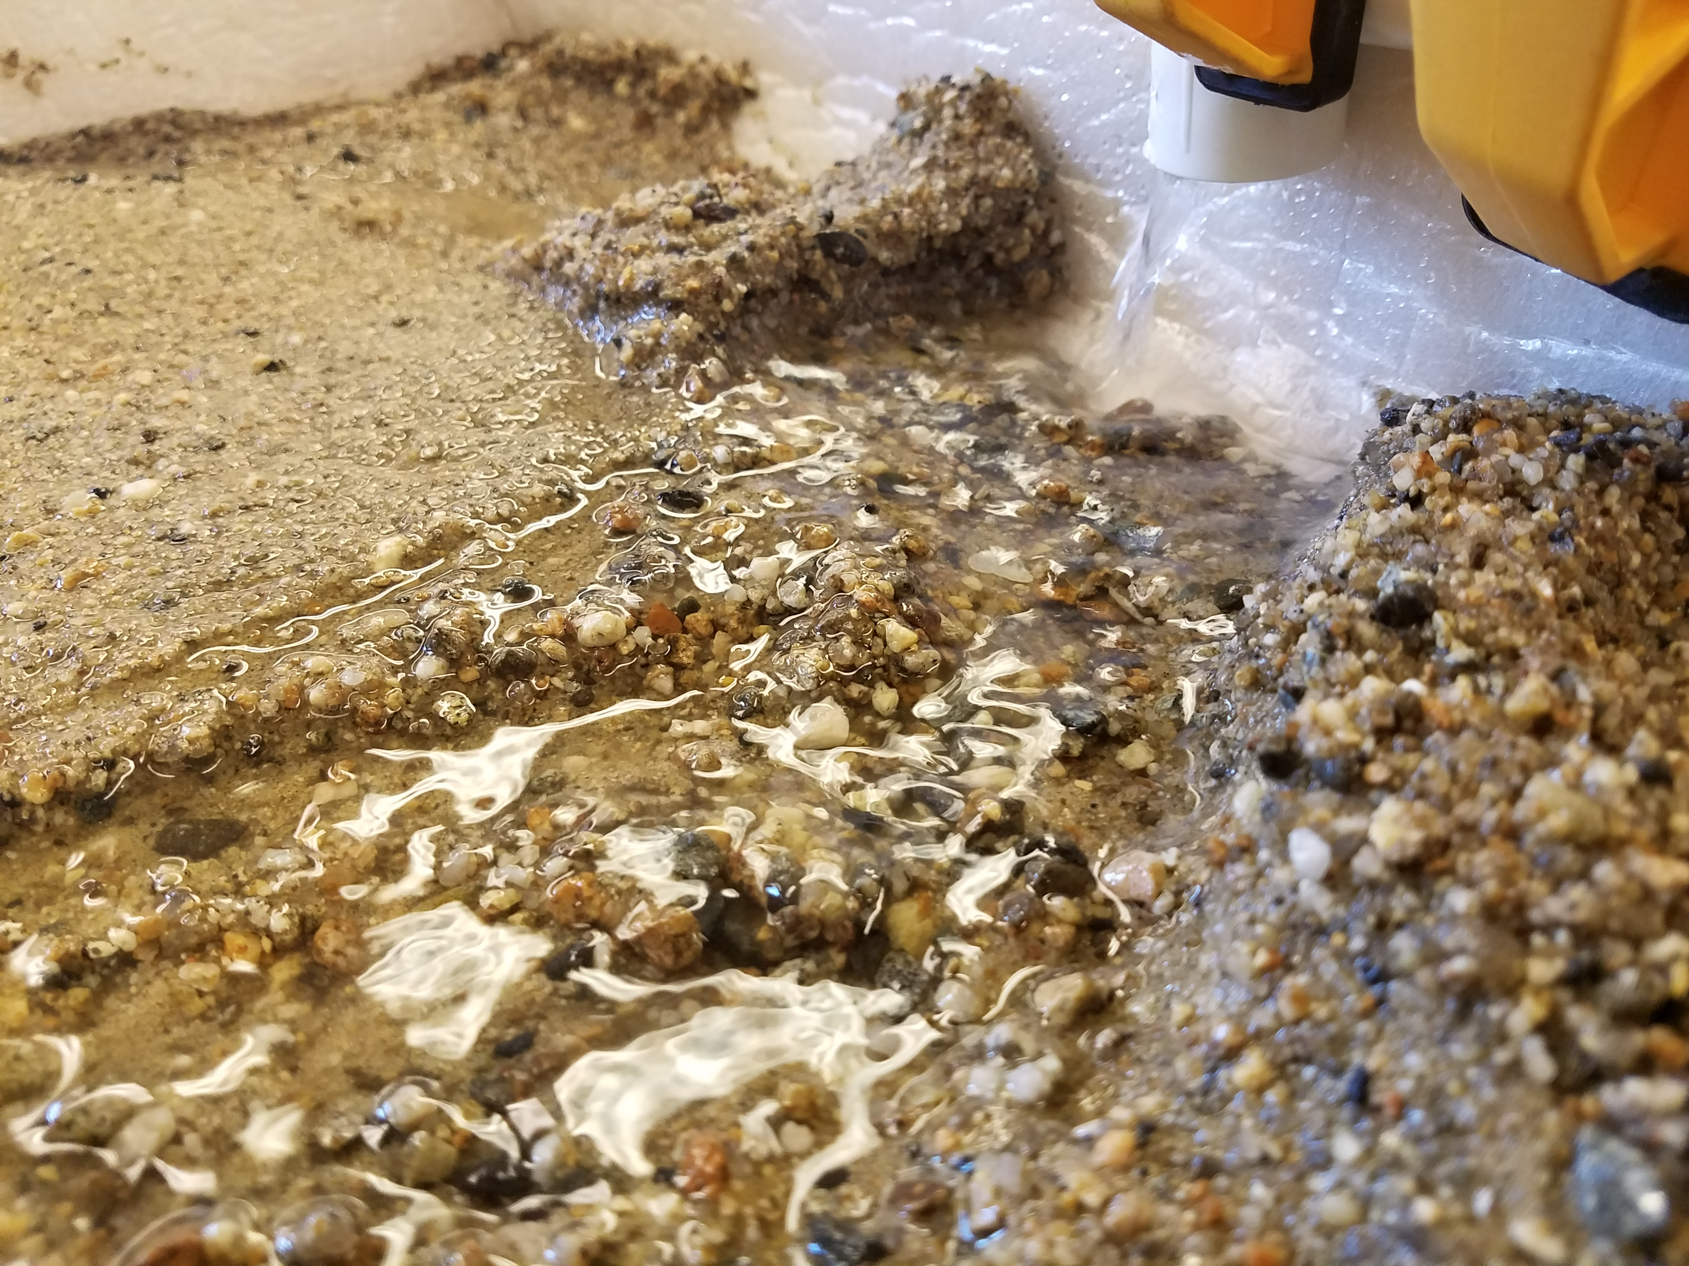

1. Adjust the beginning of your steam by changing the sand, adjust the flow rate of your pump via the C-clamp, and raise/lower the overall angle of the table until you start seeing the desired results.

# Appendix A: Tips and Tricks

* **Leveling the sand**
  + When starting a new run, taking a 2”x4” and gently raking the sand to a level surface can give a clean canvas. However, be careful not to bunch up the sand by the filter on the “low end” and create a dam, as this can turn the end of your stream into a lake.
* **Different types of sand**
  + Different types of sand will produce different results overall. Coarser, more gravel-filled sand will create a more rocky look to your results, while finer sand can have a more muddy look to it. Neither is better than the other, so consider linking whatever you use to the local ecology to make more connections.
* **Layers of different materials**
  + You can also explore layering different sands (or other materials) for different effects, as well as to better represent a real landscape. Fine sand could act as a stand-in for rich topsoil, with coarser sand underneath.
* **Pre-designed landscape**
  + Another fun thing to do is to add features and watch the effect on the new stream. Large rocks can force forks into the stream, and can also be slowly eroded and moved over time. Mountains of sand can redirect the flow, or the flow can cleave the mountain into a canyon.
* **Lighting for photos and video**
  + We find the best lighting for seeing the features in the terrain is from a very low angle, mimicking a sunrise/sunset sort of look. Depending on your room, this can be as easy as turning off the lights and letting the light from the windows be your side-lighting.
* **Time-lapse video**
  + If possible, the ability to do time-lapse video can show a lot of the process, even over a short run. We prefer mounting the camera/phone/etc at the “high end”, with the water flow coming out from beneath it.

# Appendix B: Multi-Layer Table

It is also possible to add another layer to the interior of your table, making cleanup easier and changing the look of the filter. This is *strictly* *optional*, but does add another layer of engineering for those students inclined to try it.

1. Start by placing your remaining 2”x8” flat near the “low end” of your table, as well as several 2”x4”s upright along the rest of the table, as seen below:

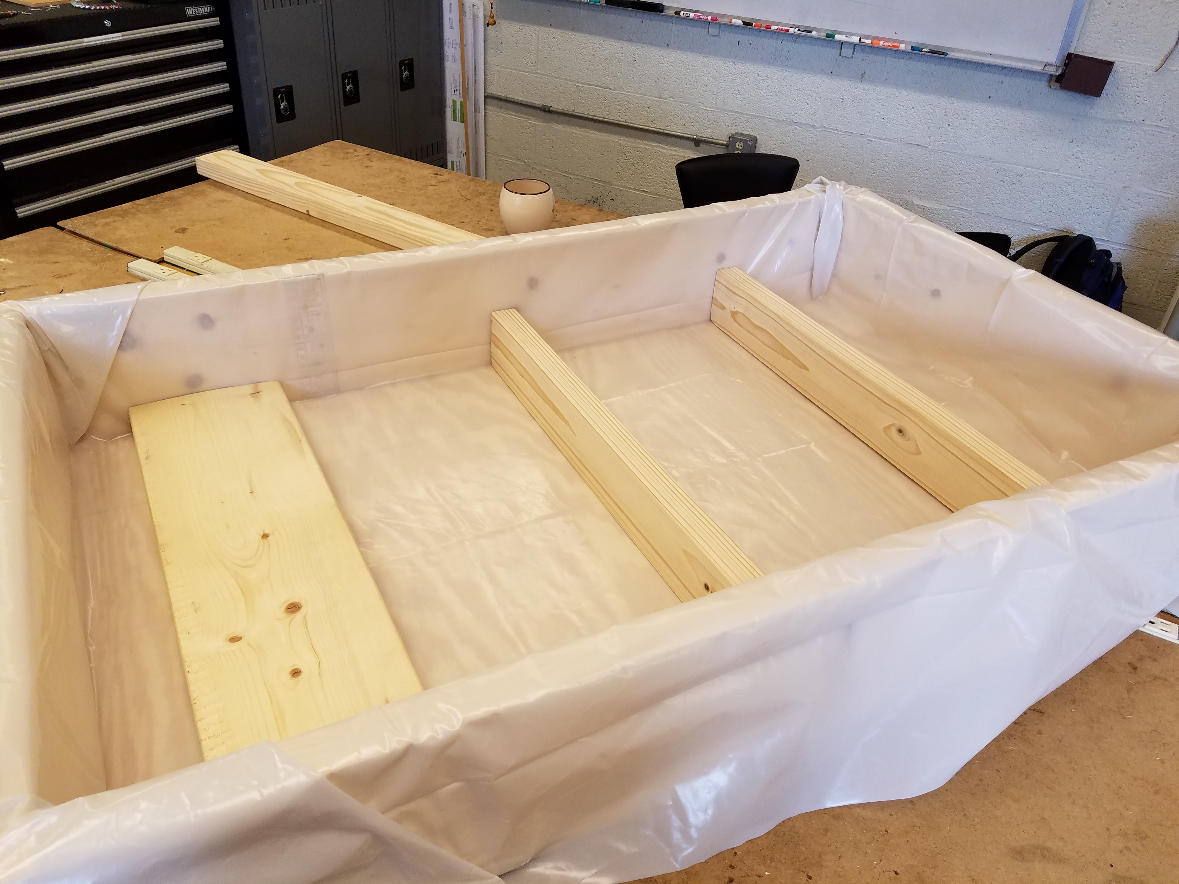

1. Cut a piece of 3/8” plywood to be 3’2” x 2’3”, and place within the box, on top of the 2”x4” “ribs”, as see below:

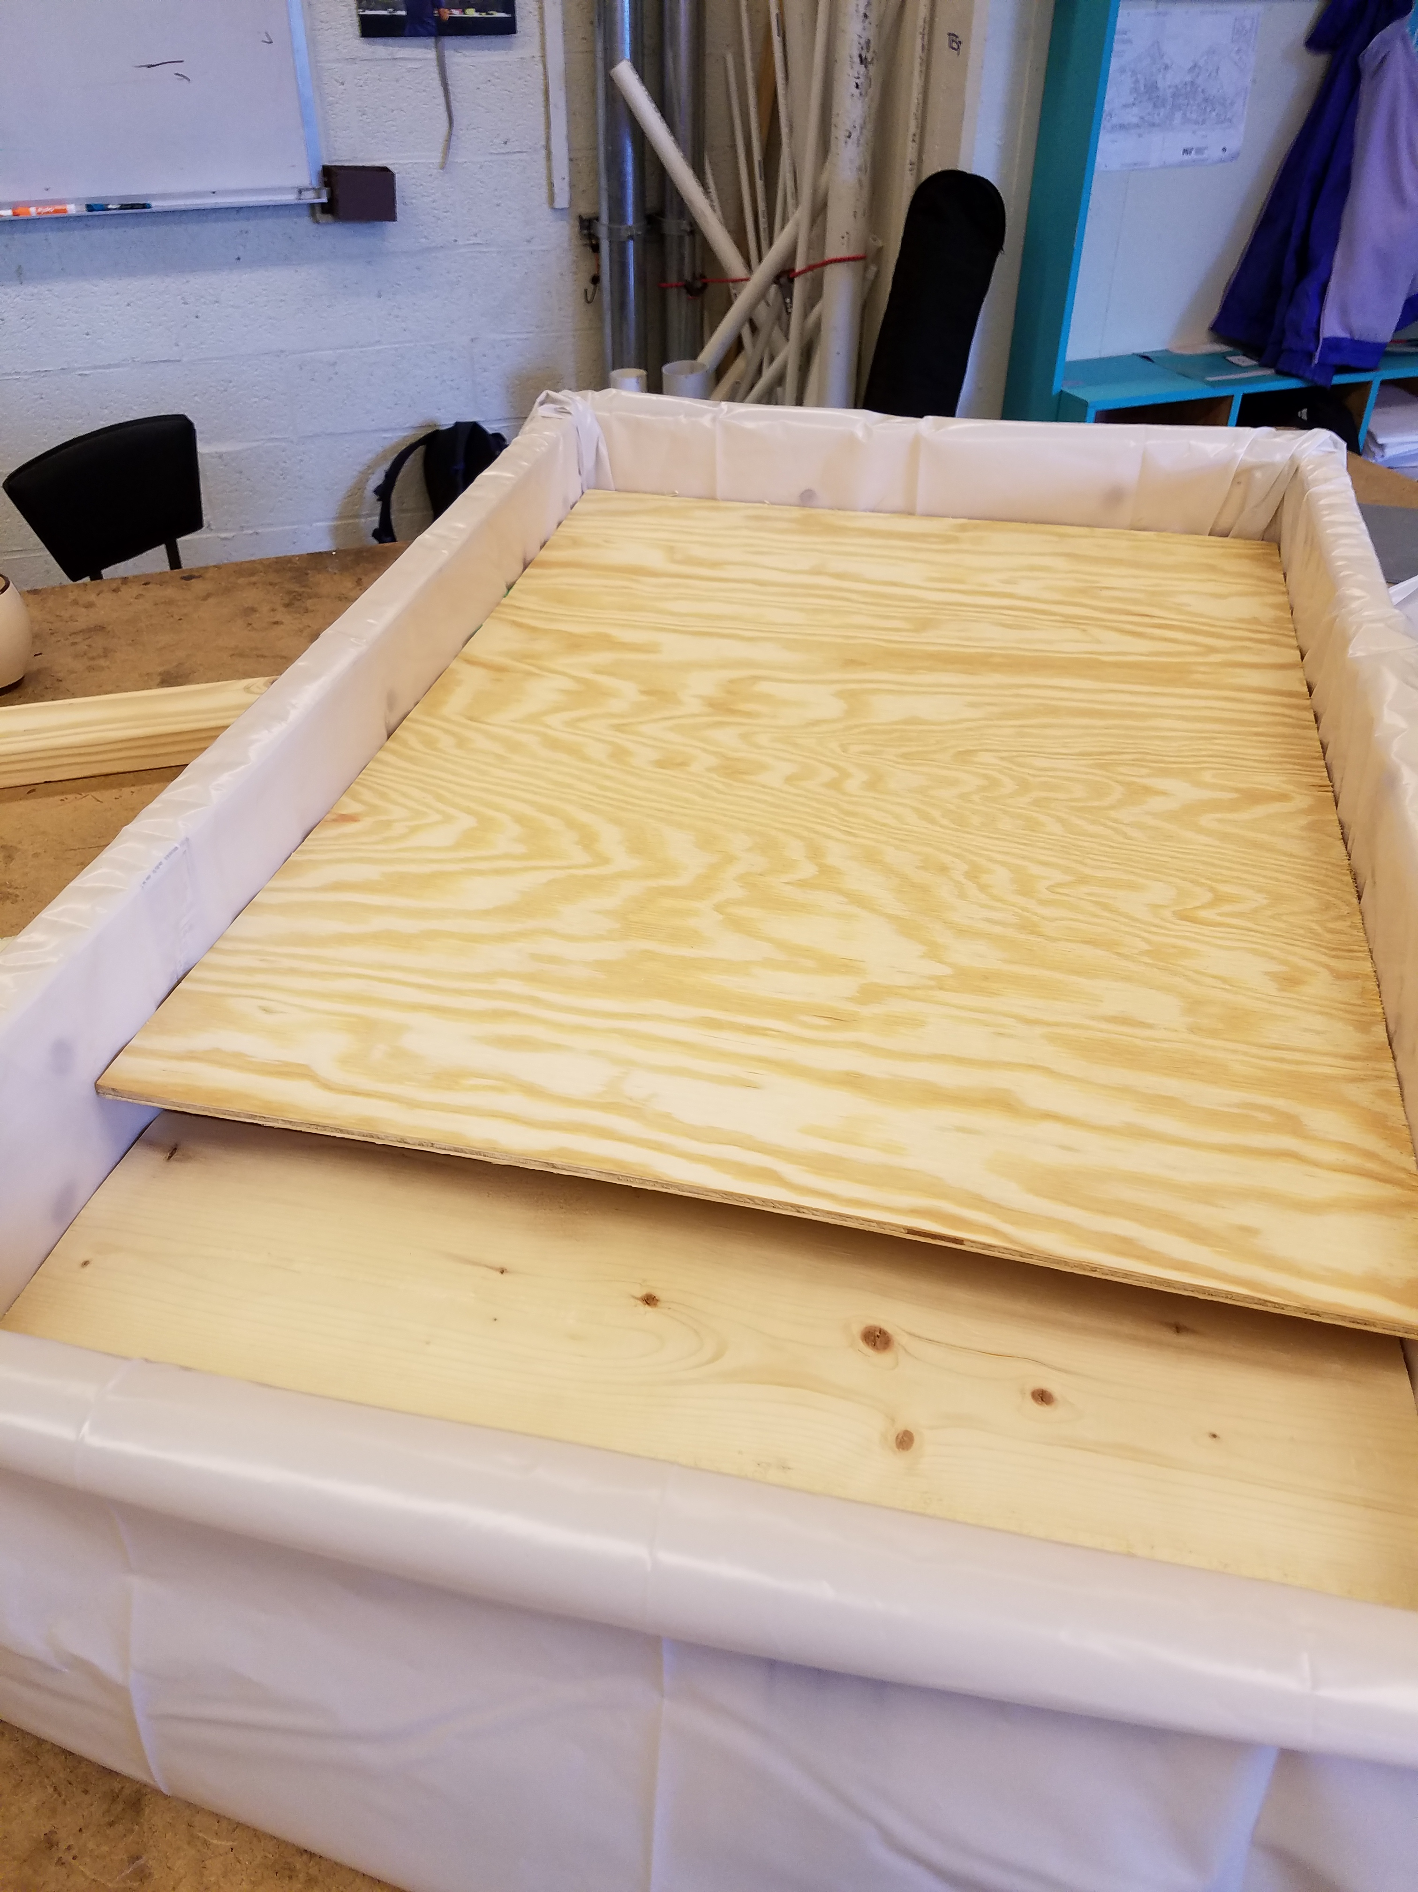

1. Take your remaining piece of plastic sheeting, and lay it across the inside of the box, conforming to the new “stairstep” pattern. Be sure to tuck some extra sheeting between the 2”x8” and the plywood above it to allow for slack. Try not to use as many staples as the first layer to allow for easier removal. When finished waterproofing, it should look like the table below:

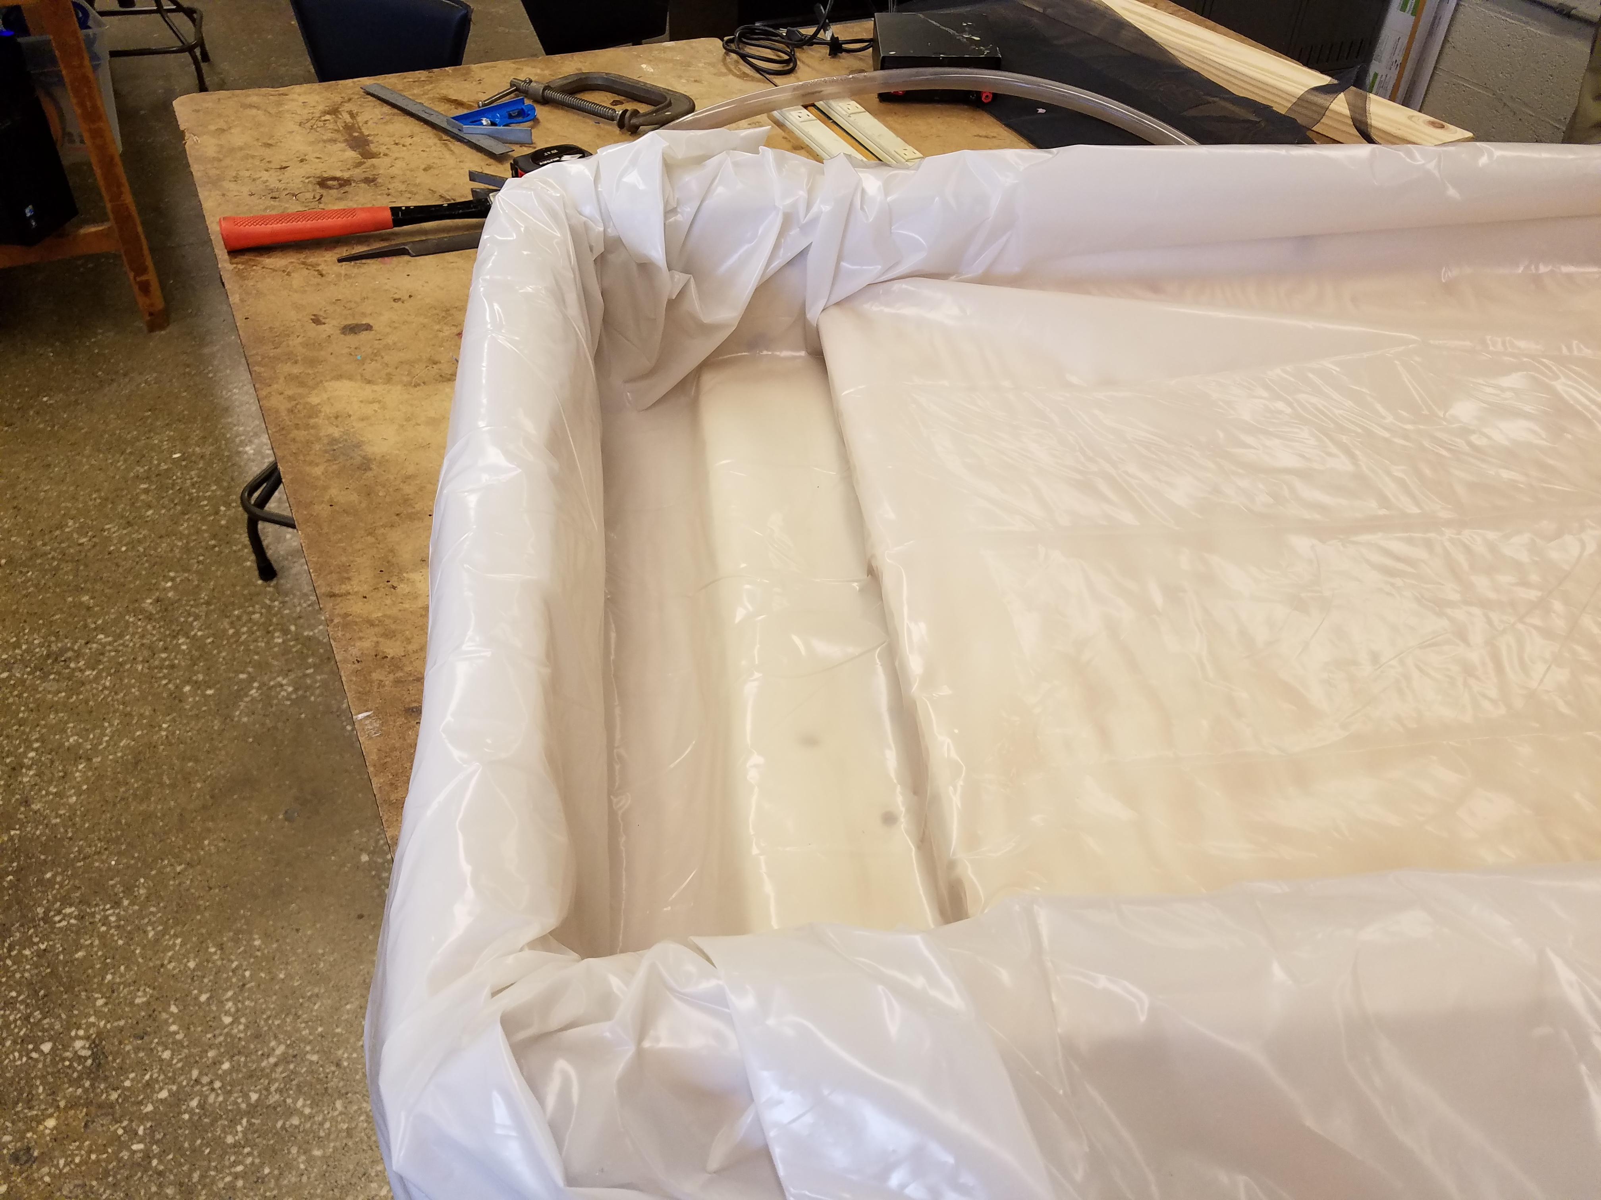

1. Place the bilge pump in the lowest section of the box, and the cheesecloth/wire mesh on the “step” above it. Make sure that the water flowing off the top layer does not flow onto the top of the filter, but down onto the 2”x8”, then sideways into the filter.

When you finish using the table, the top layer of waterproofing can be removed for easier sand disposal, while still leaving the original box intact. This allows the original box to be more readily used for other projects.

# Questions?

For questions/concerns, contact either Chris Mayer or Ed Moriarty (contact info below). Also feel free to send photos/video of your streams!

Chris Mayer

[mayerc@mit.edu](mailto:mayerc@mit.edu) (preferred)

617-324-7560

Ed Moriarty

[mory@mit.edu](mailto:mory@mit.edu)

339-223-9633 (preferred)